But this code is worst, why?

Why? Because it is going to handle only one record, but other records remain the same

Bulkified trigger is nothing, but trigger must be supported to multiple records

Now requirement is

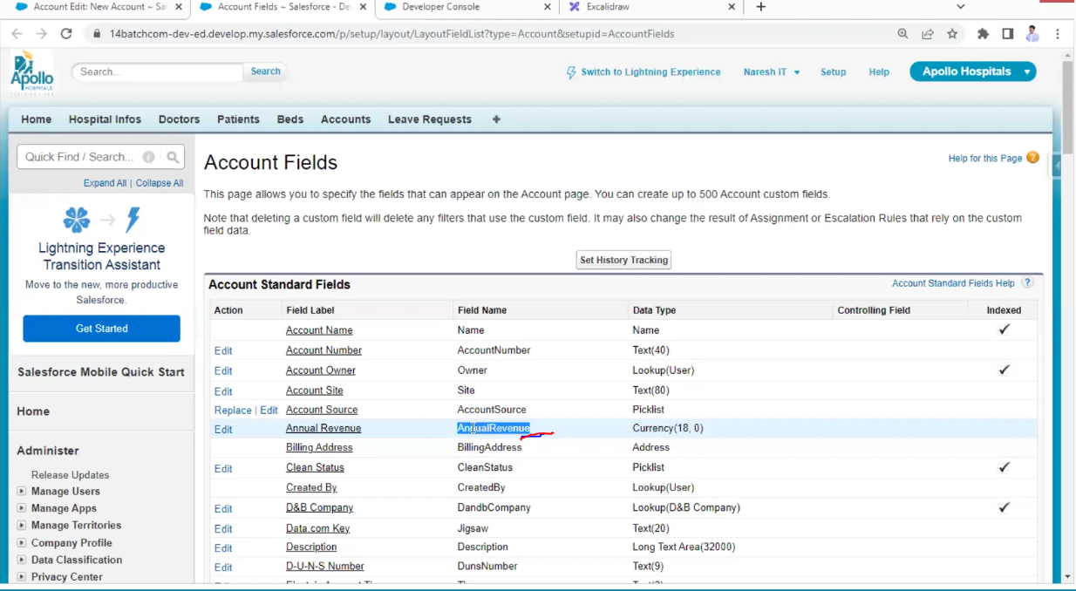

But the above code is not correct why?

For example, someone entered 40,0000 unfortunately because of trigger he is getting cold

But he changed 40lakhs to core then rating of cold is not changing here this is the draw back we are excepting hot

Only you covered insert scenario but update scenario is not covered

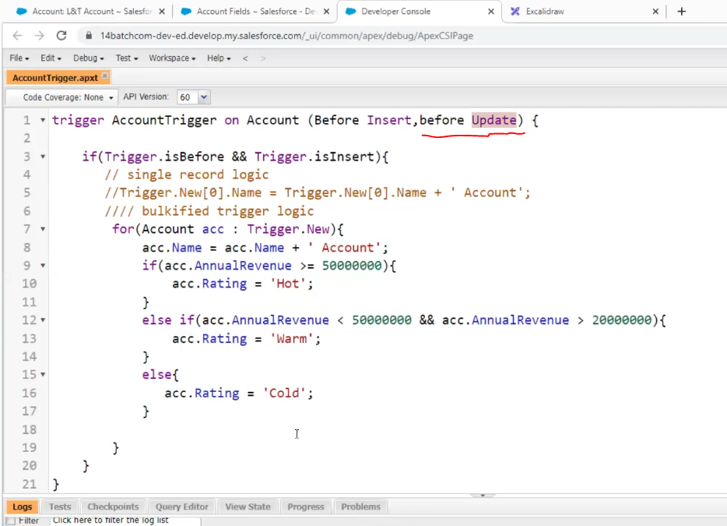

Now just update the previous record click on edit don’t change anything and then save it

Even though it is not updated check the code

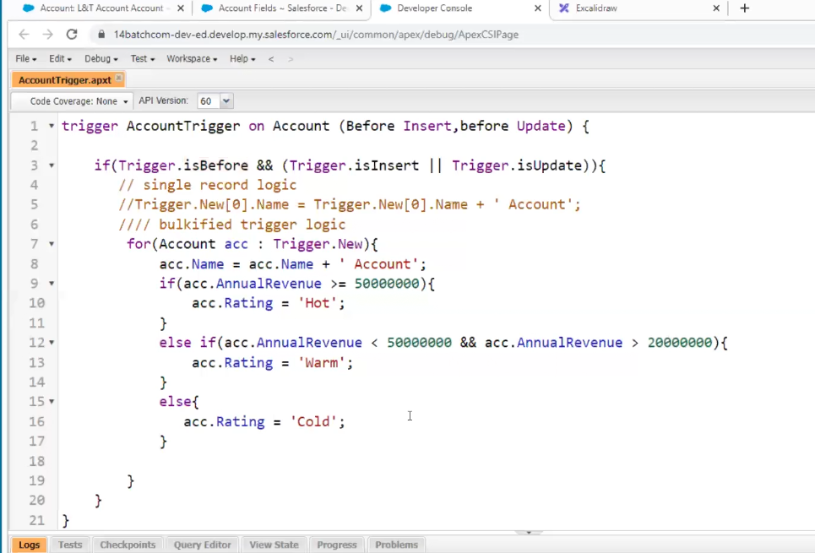

Still, why is code not efficient?

in above we have only one trigger but if have multiple triggers belongs to before insert then which trigger will execute first?

In this case the run time engine will pick random triggers

If we execute for second time it may change its execution of 3 triggers so in this case inconsistent result can occur.

So, the recommend should be one object one trigger

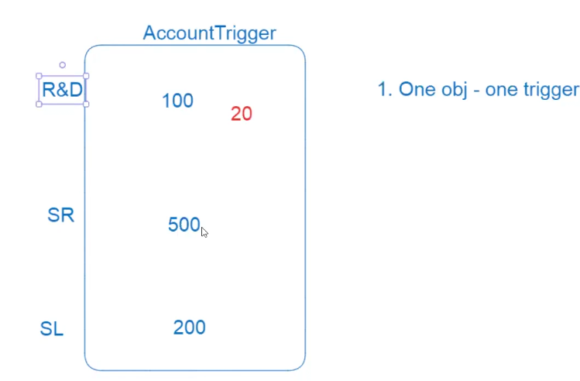

For example, it is a single trigger but different team writing with different lines but for example in R&D out of 100 lines of code in 20th line code is failed because that SR team code SL team code will not be executed even though their code was correct

SR -service team

SL-sales team



